What Is Machine Learning?
Machine learning (ML) is defined as a discipline of artificial intelligence (AI) that provides machines the ability to automatically learn from data and past experiences to identify patterns and make predictions with minimal human intervention.
The term machine learning was first introduced by Arthur Samuel in 1959
Machine learning enables a machine to automatically learn from data, improve performance from experiences, and predict things without being explicitly programmed.
With the help of sample historical data, which is known as training data, machine learning algorithms build a mathematical model that helps in making predictions or decisions without being explicitly programmed.
Machine learning brings computer science and statistics together for creating predictive models.

Use machine learning in daily life.

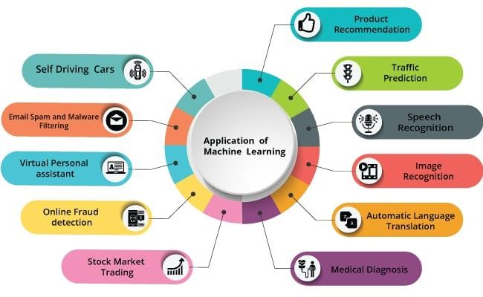

Voice Search Technology:
Machine learning algorithms enable voice-based smart assistants like Siri, Alexa, and Google Assistants to understand and respond to voice commands for various tasks such as setting reminders, alarms, and checking the weather.

Automated Translation:
Machine learning algorithms power real-time translation services like Google Translate, enabling seamless communication across different languages.

Personalized recommendations:
Machine learning algorithms analyze user behavior and preferences to provide personalized recommendations on social media platforms, e-commerce websites, and music and video streaming services.

Transportation
Machine learning algorithms calculate the quickest route with less traffic, arrival time, pick-up location, and the best optimal route to a destination, improving punctuality and efficiency.

Types of Machine Learning
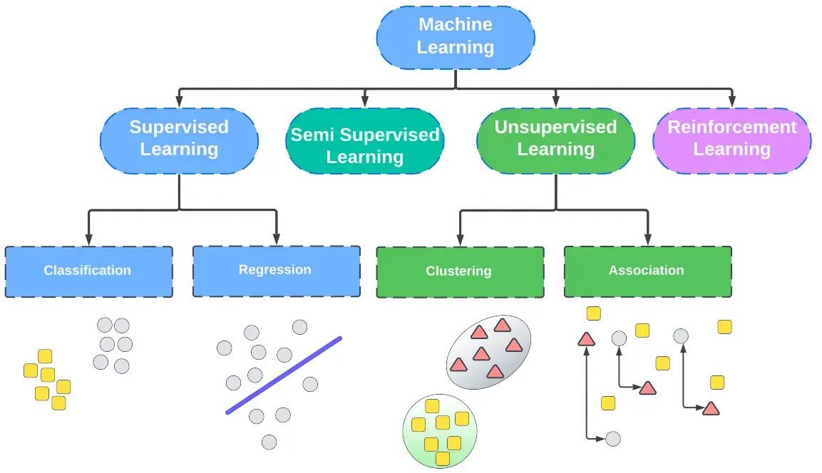

Supervised learning
Supervised learning is a type of machine learning where the model is trained on a labeled dataset, which means that both input and output parameters are provided. The model learns to map inputs to the correct outputs based on the labeled data. Supervised learning can be further divided into two categories: classification and regression. Classification deals with predicting categorical target variables, while regression deals with predicting continuous target variables.

1.Classification:
Classification is a supervised machine learning method that predicts the correct label for input data.
mail spam filtration system where one can classify a mail as either “spam(Class A)” or “not spam(Class B)”.
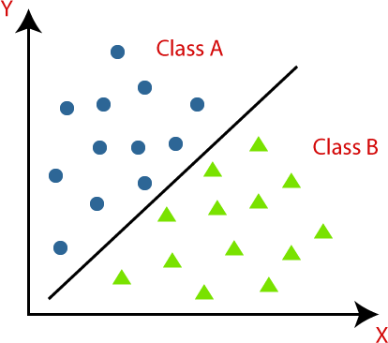

Try with code:
from sklearn import datasets
from sklearn .neighbors import KNeighborsClassifier iris=datasets.load_iris()
print(iris.DESCR) a=iris.data l=iris.target
data=KNeighborsClassifier() data.fit(a,l) predct=data.predict([[1,23,4,1]])

2.Regression:
Regression is a statistical technique that helps researchers predict or explain the variation in one variable based on another.
Example:
predicting sales based on advertising expenditure or estimating employee productivity based on hours worked.

Type of Regression:
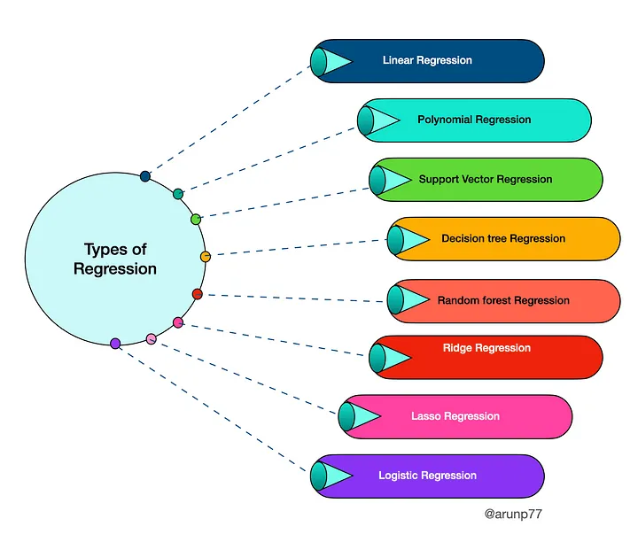

Linear Regression

Linear regression is a data analysis technique that predicts the value of unknown data by using another related and known data value. It mathematically models the unknown or dependent variable and the known or independent variable as a linear equation.

- Simple Linear Regression(SLR):

  - Simple linear regression is a type of regression analysis that models the relationship between two continuous variables, where one variable (the dependent variable) is assumed to be a linear function of the other variable (the independent variable). It is called "simple" because it involves only one independent variable.

  - The weight of the person is linearly related to their height. So, this shows a linear relationship between the height and weight of the person. According to this, as we increase the height, the weight of the person will also increase.

  - In simple linear regression, a straight line is fitted to the data points to estimate the relationship between the two variables. The equation for a simple linear regression model can be written as:

    - y = β0 + β1x + ε

where:
- y is the dependent variable
- x is the independent variable
- β0 is the intercept term of y
- β1 is the slope coefficient, which represents the change in y for a unit change in x
- ε is the error term or the random component of the model

Find b1:

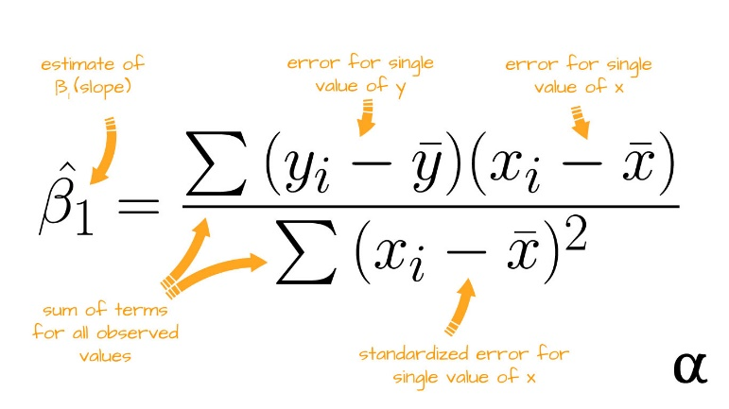

Find b0:

β0 = y̅ - β1x̅
Hours Studied (x) | Exam Score (y)
3 | 70
5 | 85
2 | 60
8 | 90
6 | 85
1 | 50
7 | 95
4 | 75
9 | 95
5 | 80

- What is intercept?

    - The intercept (sometimes called the “constant”) in a regression model represents the mean value of the response variable when all of the predictor variables in the model are equal to zero.

    - In other words, the intercept is the value of y when x equals zero, assuming a linear relationship between the two variables. It can be interpreted as the baseline value of the dependent variable, which is not affected by changes in the independent variable.

- What is slope co-efficient?

    - In the context of linear regression, the slope coefficient, denoted by β1, represents the change in the dependent variable for a one-unit change in the independent variable.

    - It is the rate at which the dependent variable changes with respect to the independent variable, assuming a linear relationship between the two variables.

    - A positive slope indicates a positive relationship between the two variables, where an increase in the independent variable leads to an increase in the dependent variable, while a negative slope indicates a negative relationship, where an increase in the independent variable leads to a decrease in the dependent variable.

- what is the best fit of line?

In regression analysis, the best-fit line is the line that most closely approximates the relationship between the dependent variable and the independent variable.
It is also known as the regression line, or the line of best fit.

- The population correlation coefficient for X and Y is given by the formula:
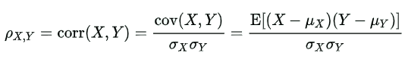
Where,
ρ_{XY} = Population correlation coefficient between X and Y
μ_{X} = Mean of the variable X
μ_{Y} = Mean of the variable Y
σ_{X} = Standard deviation of X
σ_{Y} = Standard deviation of Y
E = Expected value operator
Cov = Covariance
The sample correlation coefficient formula is:
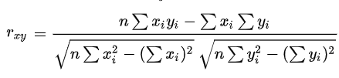

Pearson Correlation Coefficient (r)

Pearson correlation coefficient (r) | Correlation type | Interpretation | Example
Between 0 and 1 | Positive correlation | When one variable changes, the other variable changes in the same direction. | Baby length & weight:  The longer the baby, the heavier their weight.
0 | No correlation | There is no relationship between the variables. | Car price & width of windshield wipers:  The price of a car is not related to the width of its windshield wipers.
Between  0 and –1 | Negative correlation | When one variable changes, the other variable changes in the opposite direction. | Elevation & air pressure:  The higher the elevation, the lower the air pressure.

The Pearson correlation coefficient (r) is the most widely used correlation coefficient and is known by many names:
- Pearson’s r
- Bivariate correlation
- Pearson product-moment correlation coefficient (PPMCC)
- The correlation coefficient
The Pearson correlation coefficient is a descriptive statistic, meaning that it summarizes the characteristics of a dataset. Specifically, it describes the strength and direction of the linear relationship between two quantitative variables.

Pearson correlation coefficient (r) value | Strength | Direction
Greater than .5 | Strong | Positive
Between .3 and .5 | Moderate | Positive
Between 0 and .3 | Weak | Positive
0 | None | None
Between 0 and –.3 | Weak | Negative
Between –.3 and –.5 | Moderate | Negative
Less than –.5 | Strong | Negative

- When use?
    - Both variables are quantitative
    - The variables are normally distributed
    - The data have no outliers
    - The relationship is linear:
- calculating the Pearson correlation coefficient (r):
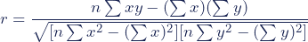

- Polynomial Regression
Polynomial regression is a type of regression analysis used in statistics and machine learning to model relationships between variables when the relationship isn't linear.

linear regression works only when the regression in the data is linear.

Polynomial Regression is a regression algorithm that models the relationship between a dependent(y) and independent variable(x) as nth degree polynomial..

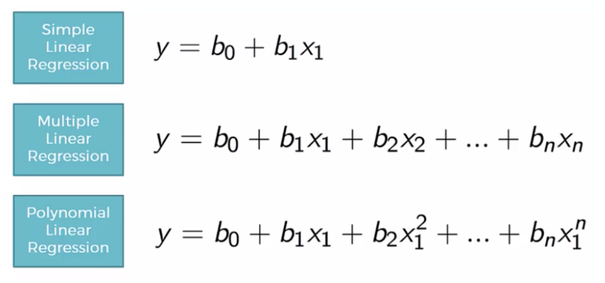

- When use

For cases where the data points are arranged in a non-linear fashion, there is a need for polynomial regression. If a non-linear model is present and you try to cover it using a linear model, it will cover no data points. Hence, a polynomial model is used to ensure that the data points are covered.

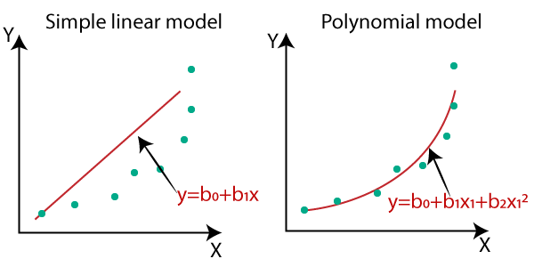

Example:

Another application of polynomial regression is in the analysis of climate data. The relationship between temperature and time is often nonlinear, and polynomial regression can be used to model this relationship and make predictions about future temperature trends.
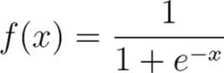
logistic regression

Logistic regression is a statistical analysis method to predict a binary outcome, such as yes or no, based on prior observations of a data set.
A logistic regression model predicts a dependent data variable by analyzing the relationship between one or more existing independent variables. For example, a logistic regression could be used to predict whether a political candidate will win or lose an election or whether a high school student will be admitted or not to a particular college. These binary outcomes allow straightforward decisions between two alternatives.
When use?
Logistic regression is used to determine one dependent variable that can only have two outcomes, e.g. pass/fail, yes/no.
Type of Logistic regression

Binary logistic regression
Binary logistic regression is used to predict the probability of a binary outcome, such as yes or no, true or false, or 0 or 1.

Multinomial logistic regression
Multinomial logistic regression is used to predict the probability of one of three or more possible outcomes, such as the type of product a customer will buy, the rating a customer will give a product, or the political party a person will vote for.

- Ordinal logistic regression

is used to predict the probability of an outcome that falls into a predetermined order, such as the level of customer satisfaction, the severity of a disease, or the stage of cancer

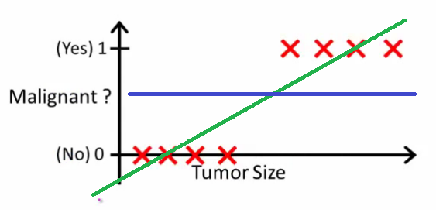
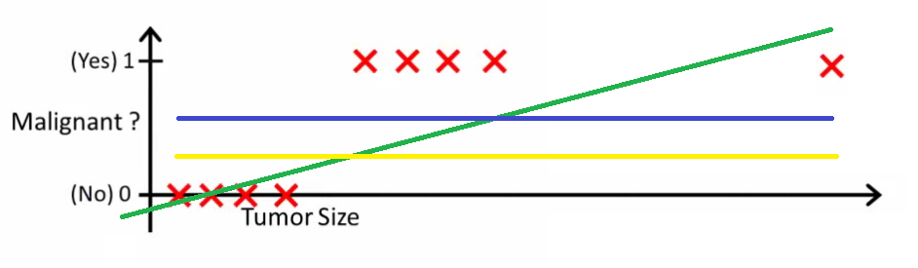

Lasso regression

Lasso regression is a regularization technique used in statistics and machine learning to improve the accuracy and interpretability of statistical models.

